# Serenity-

Serenity is bdd pattern.

You can write own step def.

They support rest assured, junit, cucumber etc and many other tools.

Go to this site and check more details-

[Welcome | Serenity BDD Users Manual (serenity-bdd.github.io)](https://serenity-bdd.github.io/)

Serenity does not support testng.

Serenity nicely maps requirement documentation to the report.

# First add in pom all the dependencies-

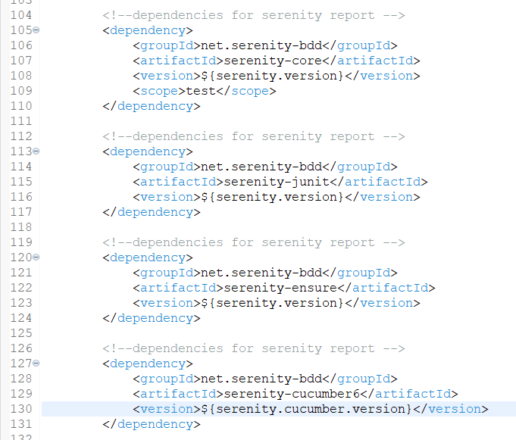

Add the versions in properties-

# Create this property file at project level-

We add surefire plugin to run test cases using maven.

We add the serenity runner file path inside the surefire plugin-

Add one more plugin for serenity report-

This will generate good serenity reports using serenity core. Goal is to aggregate all the features into one file and prepare an aggregate report.

Once all settings done, force update the project always.

# Run from cmd-



Go to the project location and run the above command.

Build success-

Inside target – site – serenity folder, lots of files generated. We don’t want to see this. We copy the entire file path and open in browser.

Click on the serenity reports link in cmd and play around with the report-

# Project structure-

# Codes from this chapter-

|  |
| --- |
| Serenity properties file-  #give any name for the project or report  serenity.project.name=serenity and cucumber quick start by Naveen |

|  |
| --- |
| Serenity runner-  **package** testRunners;  **import** org.junit.runner.RunWith;  **import** io.cucumber.junit.Cucumber;  **import** io.cucumber.junit.CucumberOptions;  **import** net.serenitybdd.cucumber.CucumberWithSerenity;  @RunWith(CucumberWithSerenity.**class**) // this is the only change when we want serenity report  @CucumberOptions(  features = { "src/test/resources/parallel/LoginPage.feature" },  glue = { "parallel" },  plugin = { "pretty"}    )  **public** **class** SerenityTestRunner {  } |